

Anzac Day 2026 – April 25

On Anzac Day we will participate in the Greensborough Anzac Day March (this is the one attended by most Banyule District Scout Groups). FULL Uniform to be worn (white scarf for New Chums!). Note that this is for Cubs and for any Scouts/Venturers/Rovers wanting to join in.

Anzac Day March
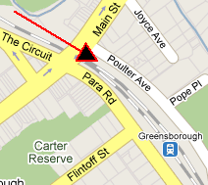
For the Greensborough march, meet at the carpark off Poulter Ave (opposite Greensborough RSL), Greensborough -
https://goo.gl/maps/m49QijcNiiqRRKrj8

Be there by 8.20am to get ready for the start.

The March will proceed up the hill to Memorial Park in Henry Street for the Anzac Service. Refreshments will be provided for all at Greensborough R.S.L. afterwards.

Remember: On top of the significance of Anzac Day for us, participation in a Service is also part of the Heritage Badge (‘Their Service, Our Heritage’). If you take part in another Anzac Day service (preferably in Uniform), please let us know so your attendance can still count.




